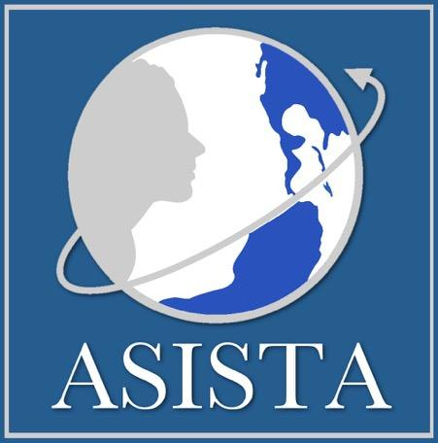
We are pleased to announce that ASISTA is serving as a national training and technical assistance provider for OVW LAV & STOP grantees and sub-grantees during the 2021-2023 grant period. We are happy to partner with you to better serve immigrant survivors of domestic violence, sexual assault, dating violence, and stalking.

OUR SERVICES

TECHNICAL ASSISTANCE (TA) & INDIVIDUAL CASE INTERVENTION

We provide comprehensive, cutting-edge technical assistance and interventions with USCIS for those assisting non-citizen survivors of violence in the immigration law arena.

Can’t find the answer to a legal question? Not sure about strategy? Case stuck at USCIS? Think USCIS made an error? Schedule a time to review your case questions with one of ASISTA's expert attorneys or join our group TA calls for OVW LAV grantees/sub-grantees and STOP sub-grantees. Log into your account here and follow the instructions.

ADVOCACY

We develop strategic and coordinated approaches to improve systems that affect immigrant survivors of violence.
Want to get connected with others? Access the ASISTA Experts listserv to connect with practitioners nationwide who are working with immigrant survivor cases.

TRAINING

We train lawyers, Department of Justice accredited representatives, and domestic violence and sexual assault advocates on best practices for helping immigrant crime survivors secure immigration status.

Attend our webinar presentations through the TA2TA platform. Register here for our upcoming events.

ASISTA ORIENTATION

ASISTA orientation webinar was presented on Tuesday, April 12th, 2022. Click here to access the recording session.
Questions? Contact Maria Lazzarino at manager@asistahelp.org

OVW Staff Attorney Kelly Head
kelly@asistahelp.org

Check out our website:
http://www.asistahelp.org

We wish to especially thank the federal Office on Violence Against
Women of the U.S. Department of Justice, which supports our work
on behalf of their grantees.

This project was supported by Grant No. 15JOVW-21-GK-02240-MUMU awarded by the Office on Violence Against Women, U.S. Department of Justice. The opinions, findings, conclusions, and recommendations expressed in this publication/program/exhibition are those of the author(s) and do not necessarily reflect the views of the U.S. Department of Justice.

