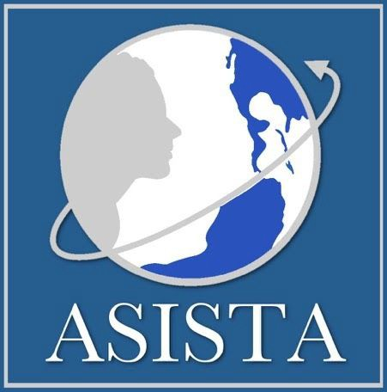

Practice FAQ:
Matter of L-N-Y-, 27 I&N Dec. 755 (BIA 2020)1

L-N-Y- does not Supercede Sanchez Sosa

- L-N-Y- decision maps L-A-B-R- factors onto Sanchez Sosa decision, but does not supercede either case.
- IJs must consider primary and secondary factors when determining whether there is “good cause” for a continuance.
- Primary Factors are:
  - Prima facie eligibility
  - Whether U visa grant will materially affect outcome of removal proceedings
- Secondary Factors include:
  - Diligence
  - Administrative efficiency
  - DHS's position

Practice Pointers

P rima Facie Eligibility: USCIS should make prima facie determination (PFD) because it has training and jurisdiction over U visa petitions. Ask IJ to order ICE Office of the Chief Counsel (OCC) to request a PFD from USCIS and argue that this request will result in administrative efficiency for the court. As an alternative, IJ has to make PFD pursuant to Sanchez Sosa and in order to meet the L-N-Y-criteria for a good cause assessment.
M aterially Affect Outcome of Proceedings: BIA agreed in L-N-Y- that U visa grant
would materially affect outcome of proceedings

D iligence: Distinguish your facts from L-N-Y-. If there is a delay between
qualifying crime and U visa application, explain why. Get this in the record.

A dministrative Efficiency: Argue that, 1) denying continuance/ordering removal is
not more efficient because the court will have to adjudicate a motion to reopen

1 For a more detailed analysis of Matter of L-N-Y-, take a look at ASISTA’s Practice Advisory: The Impact of Matter of L-N-Y-, 27 I&N 755 (BIA 2020).
once U visa status is approved; and 2) delay in U visa petition processing is USCIS's fault (and OCC's, if OCC is refusing to request expedite), not respondent's. If you are in the 4th Circuit, argue for administrative closure as the most efficient option pursuant to Zuniga-Romero v. Barr, 937 F.3d 282 (4th Cir. 2019).
D HS's Position: If on waitlist, IJ should discount opposition from DHS because
DHS policy is to respect waitlist deferred action. If your client is not on the waitlist, IJ should still discount opposition if DHS refused to request PFD and/or expedited adjudication as this is essentially a refusal to reduce delay and administrative inefficiency by USCIS, which is part of the same agency.

Arguments for challenging BIA’s reasoning in L-N-Y:

- BIA erred in giving excess credence to DHS’s position in L-N-Y-:
  - U visa petitioners cannot simply obtain a U visa overseas. Removal will trigger 212(a)(9)(A) and probably 212(a)(9)(B), and petitioner must apply for and obtain a waiver of these additional grounds.
  - Congress intended the U visa to facilitate cooperation with LEAs by reducing fear of deportation. The intention was not to deport people and then let them come back to the US.

If you have questions about your case, ASISTA Members can submit a Request for Technical
Assistance at w ww.asistahelp.org. Not a Member yet? Join ASISTA today!

The information provided in this FAQ is legal information only and does not constitute legal advice. Copyright © 2020 by ASISTA Immigration Assistance. All rights reserved. This product or any portion thereof may not be reproduced or used without express written permission from ASISTA Immigration Assistance.

