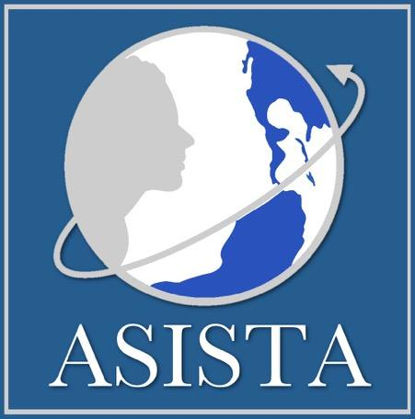

Visit us online at www.asistahelp.org
PO Box 12, Suffield, CT 06078
Phone: (860) 758-0733
E-mail: questions@asistahelp.org

VAWA Updates/ASISTA Experts/U Visa Litigation Listserv Application
Please fill out this form and send by e-mail to ASISTA, Attn: ASISTA Manager

Name:
Title:
Organization:
Address:
City, State, Zip:
Phone Number
Email Address:

ASISTA Listserv information:

VAWA Updates is an open list to receive news, updates, and invitations to our training and events.

ASISTA Experts is a discussion listserv for people with significant expertise in immigration law and a high VAWA caseload. It isn’t for anyone just doing cases. Please review the commitments below and if you are unwilling to make these commitments, then this is not the listserv for you. This is a private list, open ONLY to ASISTA private members, and OVW grantees.

U Visa Litigation Group is an open interactive discussion list focusing on litigation strategies.

Your commitments:

- Those who participate must be willing to help develop and implement efforts to remedy problems;

- If you participate in a local network you must take responsibility for communicating to this network what you learn and what we plan to do;

- To be in ASISTA Experts you must also be on the VAWA Updates Listserv.

_____ I have read and agree to the preceding commitments and would like to join BOTH the ASISTA Experts and the VAWA Updates Listservs

_____ I am ONLY interested in joining the VAWA Updates Listserv

_____ I am m ONLY interested in joining the U Visa Litigation group

I am not an immigration attorney/advocate but have been working on immigrant victims of partner violence projects:

Does your agency receive OVW funds? _____ YES _____ NO

Does your program receive STOP/LAV grant funds? _____ YES _____ NO

Do you provide direct legal assistance to clients? _____ YES _____ NO

________ I have read the ASISTA Experts listserv disclaimer and I agreed with the listserv rules and responsibilities

