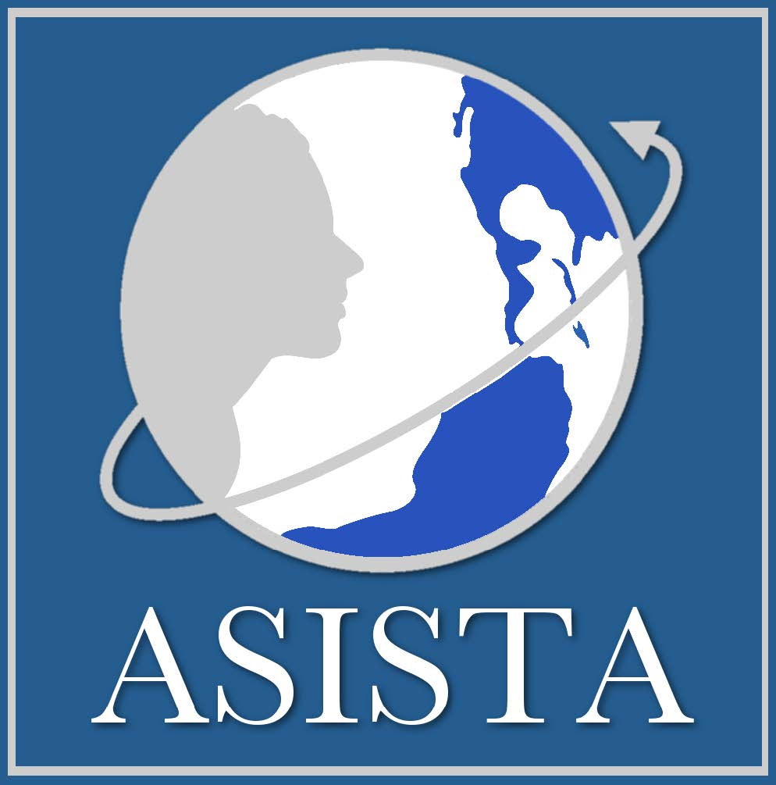

ASISTA Litigation Consultant
DEADLINE = February 22, 2019

The current administration is undermining the safety net Congress created to stop violence against immigrant women in the United States. To defend against these attacks and with support from Borealis Philanthropy, ASISTA seeks to hire a part-time Litigation Consultant who will work with Executive Director Gail Pendleton to focus on litigation and FOIA strategies that will (1) challenge policies that endanger immigrant survivors of domestic and sexual violence and human trafficking and (2) expand our technical assistance to impact litigators wishing to incorporate immigrant survivors and their issues into litigation efforts to advance the rights of immigrants generally.

The specific tasks below are the primary targets for this project, but we retain flexibility to address new issues as they emerge and to continue supporting other litigation in this area. Note that the focus of this project is coordinating litigation nationally, not necessarily filing litigation on behalf of ASISTA, although that remains an option as we craft aggressive challenges to governmental attacks on survivors.

Targeted Projects
Explore and coordinate impact litigation and FOIA efforts to challenge:

- USCIS plans to issue Notices to Appear (NTA) against VAWAs, Us and Ts who are denied status, often wrongfully;
- Fee waiver denials, and constructive case denials resulting from fee waiver denials, for VAWA, U and T applications.

Provide technical assistance and content expertise to:
  - Immigration (and other) attorneys wishing to litigate individual survivor cases
  - Impact litigators seeking to incorporate survivor-based arguments and plaintiffs into their immigrants' rights litigation
  - Help both new and seasoned litigators frame/craft arguments for survivor-issue litigation

Oversee and facilitate the U litigation list serve and
- Incorporate grassroots organizational allies into litigation campaign strategies
- Ensuring our litigation campaigns dovetail with other change strategies and efforts

Qualifications
- Law degree (or DOJ recognition) plus five years' experience representing survivors on VAWA self-petitions and U visas
- Experience in immigration and federal court
- Demonstrated ability to work under remote supervision
- Demonstrated ability to work in a team leadership model
- Excellent analytic, advocacy and communication skills
- Bi- or multi-cultural and -lingual candidates favored but not required

The Details
$50/hour, 25 hours/week, 11-12 months

By Friday, Feb. 22, 2019 send to ahlam@asistahelp.org:
- Cover letter
- Resume
- Writing sample, and
- References

Final candidates will participate in individual phone/online interview, which may entail homework related to the job tasks. We hope to make the final hire by March 1.

Working for ASISTA
ASISTA consultants may work anywhere in the US; all ASISTA staff work out of their homes. ASISTA’s mission is to advance the rights, dignity and liberty of immigrant survivors of violence. We are an Equal Opportunity/Affirmative Action employer, committed to excellence through diversity. We strongly encourage people of color, women, and members of other groups subject to historic and/or current discrimination and under-representation in U.S. society to apply.

